Program & Professional Development Committee
Annual Report for 2021-2022

Committee Members:
Margaret Danowski, Co-Chair/President-Elect
Jill Turner, Co-Chair
Margaret Hoogland, President
Bethany Figg
Merle Rosenzweig
Wendy Wu

Accomplishments
Three General Business Meetings and four additional educational programs were planned and conducted. One of the Fall programs was a funded MLA CE webinar. Due to COVID-19, all events were virtual except for the 2022 Summer Luncheon which was in-person with a virtual program option. There was no Spring Business meeting. Instead, Margaret Hoogland, MDMLG President, held three WebEx bylaws discussion sessions for members to provide input on the proposed bylaw changes drafted by the Executive Board.

September 16, 2021: Fall General Business Meeting and Webinar.
The Program & Professional Development Committee provided a Fall General Business Meeting and webinar opportunity. The day included the business meeting and a virtual presentation "Repurposing and Using FDA Approved Drugs to Treat Existing Illnesses," by Dr. Robert McCullumsmith, College of Medicine and Life Sciences, The University of Toledo.

October 20, 2021: Fall Educational Program, MLA CE Webinar.
The Program & Professional Development Committee provided a Fall Educational Program titled "Better, Faster: An Introduction to Systematic Review Automation Tools” presented by Justin Clark, Senior Research Information Specialist, Institute for Evidence-Based Healthcare, Bond University. This was a live viewing of a 1.5-hour CE MLA Webinar.
November 1, 2021: Fall Educational Program, Webinar.
The Program & Professional Development Committee provided a Fall Educational Program titled "Authorship and Acknowledgement in Systematic Reviews & Evidence Syntheses," presented by Whitney Townsend, Informationist, Taubman Health Sciences Library, The University of Michigan.

February 10, 2022: Winter General Business Meeting and Webinar.
The Program & Professional Development Committee provided a Winter General Business Meeting and webinar opportunity. The day included the business meeting and a virtual presentation "From Bordeaux to BiDil: How Science and Medicine Invented Race," by Prasad Venugopal, Department of Chemistry and Biochemistry, University of Detroit-Mercy.

March 7, 2022: Spring Educational Program, Webinar.
The Program & Professional Development Committee provided a Spring Educational Program titled "Cyber Hygiene for Librarians," presented by Weiqing Sun, Computer Science and Engineering Technology, Program Director for Masters Program in Cyber Security, The University of Toledo.

April 7, 2022: Spring Educational Program, Webinar, Panel Discussion.
The Program & Professional Development Committee provided a Spring Educational Program titled "Familiarize Yourself with Data: Data Management.” This was an online panel discussion. Panelists booked included Jake Carlson, Director of Deep Blue Repository and Research Data Services, The University of Michigan; Erin Foster, Service Lead, Research Data Management Program, University of California, Berkeley and Rebecca Renirie, Medical Librarian, Central Michigan University. Unfortunately, just prior to the event, Jake Carlson was unable to attend but he provided his PowerPoint slides which have been posted to the MDMLG website.

June 2, 2022: Summer General Business Meeting and Luncheon.
The Program & Professional Development Committee provided a Summer General Business Meeting, networking lunch and a program which took place at the Portofino Restaurant in Wyandotte. This was the first in-person meeting since the COVID-19 pandemic began in March 2020. The program was titled “Shipwrecks and Archaeology” and was presented by Ellen Kennedy, Education and Visitor Experience Director, National Museum of the Great Lakes, Toledo. The program was streamed live for those who could not attend the luncheon in-person.

A summary of the programs with the number of registrants for each event is in the table below:

Webinar Title | Date | Live Viewing Offered? | # Registrants
Fall Business Meeting and Webinar, "Repurposing and Using FDA Approved Drugs to Treat Existing Illnesses," Dr. Robert McCullumsmith | Sep 16, 2021 | Yes | 27
MDMLG Fall Educational Program, MLA CE Webinar, “Better, Faster: An Introduction to Systematic Review Automation Tools,” Justin Clark | Oct 20, 2021 | Yes | 23
MDMLG 2nd Fall Educational Program, “Authorship and Acknowledgement in Systematic Reviews & Evidence Syntheses,” Whitney Townsend | Nov 1, 2021 | Yes | 24
Winter Business Meeting and Webinar, “From Bordeaux to BiDil: How Science and Medicine Invented Race,” Prasad Venugopal | Feb 10, 2022 | Yes | 28
MDMLG Spring Educational Program, "Cyber Hygiene for Librarians," Weiqing Sun | Mar 7, 2022 | Yes | 26
MDMLG 2nd Spring Educational Program, Panel Discussion, “Familiarize Yourself with Data: Data Management,” Jake Carlson, Erin Foster & Rebecca Renirie | Apr 7, 2022 | Yes | 33
Summer Business Meeting/Luncheon and Program, “Shipwrecks and Archaeology,” Ellen Kennedy | Jun 2, 2022 | Yes | 28  (27 in-person,  7 virtual)

Overall, attendance for the 2021-2022 programming was good, especially in light of the ongoing COVID-19 pandemic. And the first in-person event, the Summer Luncheon, was very successful. Prior to that event, a survey was sent to the membership to gauge member preferences in having an in-person or virtual event. The majority preference was for an in-person event with masks optional. Social distancing for the tables was considered acceptable. A virtual program option was provided for those members who didn’t feel comfortable attending an in-person event.

MLA 2021 Webinar Survey.
A webinar interest survey was sent to the MDMLG listserv in Summer 2021 and results were collated on August 18, 2021. Five webinars were included in the survey and participants were asked to rank the offerings on a scale of 1-5, where 1 indicated the highest interest in viewing and 5 indicated the lowest interest in viewing. 28 MDMLG members participated in the survey. From this survey, it was determined that the majority of survey respondents were interested in the "Better, Faster: An Introduction to Systematic Review Automation Tools” webinar. This MLA CE webinar was selected as the first Fall educational program. The following graphic shows the breakdown of the survey results:

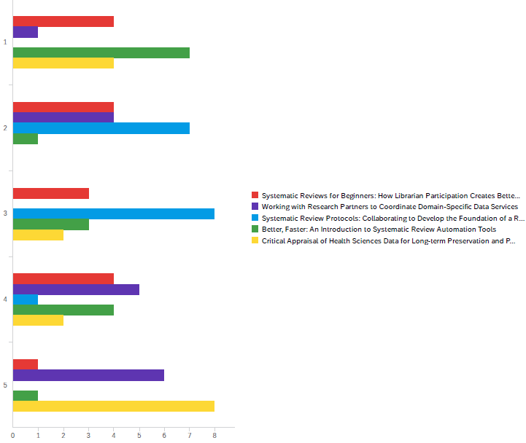

Certificates of Recognition were created and emailed to all officers and committee members as an acknowledgement for their service to MDMLG for the 2021-2022 year.

Retiring member, Valerie Reid, was acknowledged for her contributions to MDMLG at the Summer Business Meeting. In addition, the passing of MDMLG member Karin Werner was memorialized at that time.

A final expense report was submitted to the Treasurer. Except for the Summer Luncheon, all events were offered free and virtual. Only one event was funded and that was the October 20, 2021 CE event. The committee incurred expenses for three honorariums, room and catering fees for the Summer Luncheon and accrued revenue for Summer Luncheon attendance. Bethany Figg provided an institutional donation to cover the creation of booklets for the Summer Luncheon.

Respectfully submitted,

Margaret L. Danowski
Program & Professional Development Committee Co-Chair
President-Elect

